**Comparative and Superlative Forms**

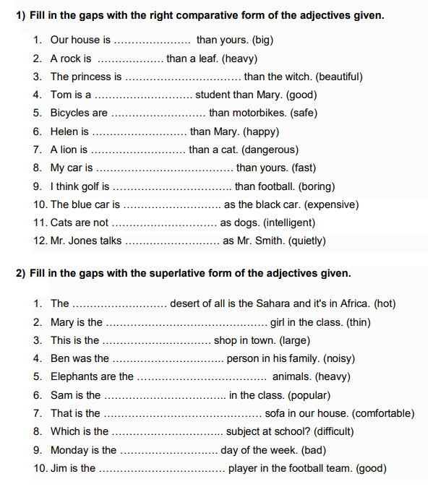

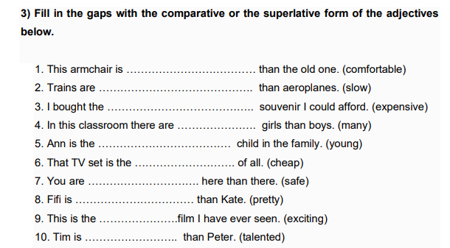

Equality

4) Write the comparison of equality for the sentences below. Use the words in brackets ( ). As…as (not as….as)

1. John is 1 metre 80cms tall. Dave is 1 metre 80cms tall. (is/tall)
2. Seville is 40ºC in summer. Cordova is 40ºC in summer. (is/hot)
3. John is not very clever. Mary is cleverer. (is/clever)
4. The blue car is not expensive. The red car is more expensive. (is/expensive)
5. The brown house is 100 years old. The green house is 100 years old. (is/old)
6. The impala runs 90km per hour. The cheetah runs 120km per hour. (run/fast)
7. The first exam was difficult. The second exam was difficult too. (was/difficult)
8. Ciudad Real is not very beautiful. Seville is more beautiful. (is/beautiful)